CURRICULUM- VITAE

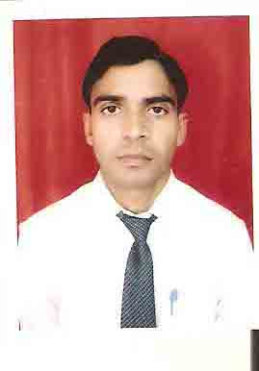

Address: -
Village- Narottampur
Post- Naipura (BHU)
Varanasi -221011
U.P
E-mail ID – dkmca85@gmail.com
Mobile No.--- 08563002256

DHARMENDRA Kumar
(DATA ANALYST (OMS), PuVVNL)

CAREER OBJECTIVE:

Seeking a challenging and progressive carrier using my inner strengths, professional skills and creative thinking to gain further exposure, strength and experience.

ACADEMIC QUALIFICATION:

- Passed B.A. from V.B.S. Purvanchal University, Jaunpur in 2008
- Passed 12th from U.P. Board in 2004
- Passed 10th from U.P. Board in 2001
PROFESSIONAL QUALIFICATION:

Passed M.C.A. from U.P. Technical University, Lucknow with 68.48 % in 2012

EXPERIENCE :
➢ 2 years 7 Months working (01-SEP-2014 to 31-March-2017) in Mobineers Infosystems Pvt. Ltd.New Delhi as a Project Manager (CCHM), PuVVNL Project

➢ 2 years working (01-April-2017 to 31-March-2019) in Rama Infotech Pvt. Ltd. Lucknow as a Project Manager (OMS), PuVVNL Project.

➢ Last 3 years working (01-April-2019 to 31March 2022) in Mobineers Infosystems Pvt. Ltd. New Delhi as a Project Manager(OMS),PuVVNLProject
➢  Currently working (01-April-2022 to Till date ) in Mobineers Infosystems Pvt. Ltd. New Delhi as a Data Analyst (OMS), PuVVNL Project

HOBBIES
- Listening music and watching movies.
- Playing Cricket

PERSONAL DETAILS
Date of Birth : 1th Nov 1985
Father's Name : Shri Jayshri Patel
Mother’s Name : Maharani Devi
Nationality : Indian
Status : Married
Language known : Hindi, English
Permanent Address : Village- Narottampur
Post- Naipura (B.H.U) Varanasi
Pin Code-221011

Mobil No.- 08563002256
Date…………….
Place…………… (Dharmendra Kumar)

